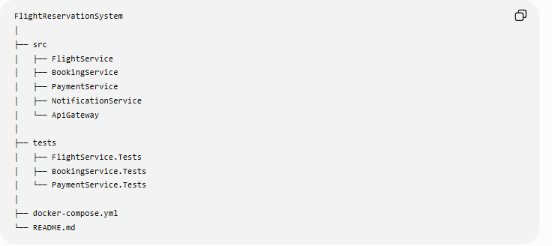
public class Flight
{
public int Id { get; set; }
public string FlightNumber { get; set; }
public string Origin { get; set; }
public string Destination { get; set; }
public DateTime DepartureTime { get; set; }
public int Capacity { get; set; }
public int AvailableSeats { get; set; }
}

public class Passenger
{
public int Id { get; set; }
public string Name { get; set; }
public string Email { get; set; }
}

public class Booking
{
public int Id { get; set; }

public Flight Flight { get; set; }
public Passenger Passenger { get; set; }

public BookingStatus Status { get; set; }
}

public enum BookingStatus
{
Reserved,
Confirmed,
Cancelled
}

public class Payment
{
public int Id { get; set; }
public decimal Amount { get; set; }

public Booking Booking { get; set; }
public PaymentStatus Status { get; set; }
}

public enum PaymentStatus
{
Pending,
Completed,
Failed,
Refunded
}

public class Notification
{
public int Id { get; set; }
public string Message { get; set; }
public Passenger Passenger { get; set; }
public Booking Booking { get; set; }
}

